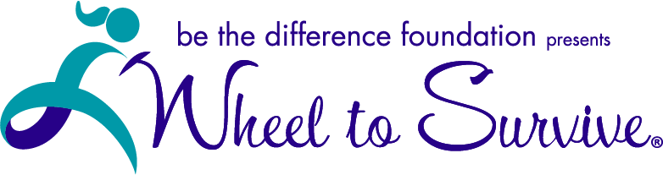

SOUTH CAROLINA
2021

SPONSORSHIP OPPORTUNITIES

JOIN US FOR THE RIDE OF YOUR LIFE!

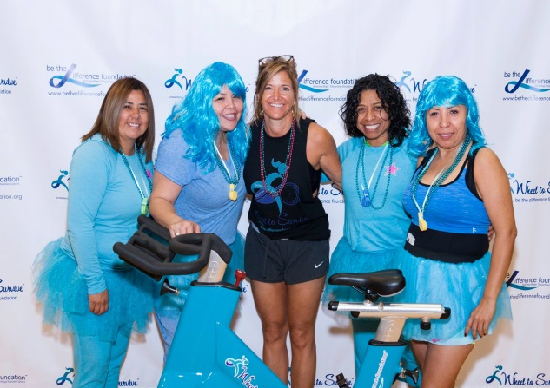
BE A PART OF WHEEL TO SURVIVE SOUTH CAROLINA 2021…
Wheel to Survive, presented by Be the Difference Foundation, is a socially distanced, indoor and outdoor stationary cycling fundraising event where dollars raised by the riders go to help women increase their chance of survival of ovarian cancer.

Ride with us in the fight against ovarian cancer on March 13th from 12pm to 3 pm Upstate and in the Low Country!!

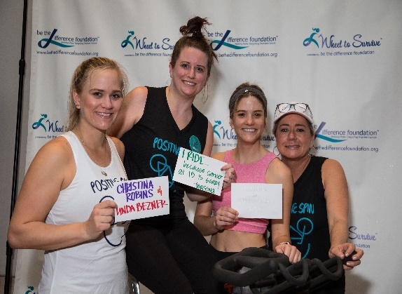
EVENT DETAILS…
On March 13, 2021, Be The Difference Foundation will hold South Carolina’s first Wheel to Survive event! In partnership with the South Carolina Ovarian Cancer Foundation and Teal Diva, simultaneous events Upstate in Greenville and in the Low Country in Charleston will raise dollars benefiting early detection research being done by Dr. Larry Puls and Dr. Terri Bruce at Prisma Health and Clemson University. All levels of riders are welcome from beginners to seasoned cyclists. Registration fees are $40 for the 3 hour event. Participants can form a relay team or ride as individuals at an hour of their choosing. Each rider gets a personal fundraising page and all dollars raised count torward their individual and team goals.

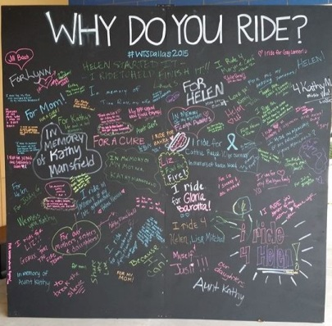
WHY WE NEED YOUR HELP…
One woman is diagnosed with ovarian cancer every 24 minutes. One woman dies from ovarian cancer every 37 minutes. 7 out of 10 women diagnosed with ovarian cancer will die from the disease. Sadly, there is no routine, reliable early detection test for the disease. Research shows that when ovarian cancer is detected and treated early, the five-year survival rate is greater than 92%. Often symptoms are vague and subtle, and unfortunately most patients are diagnosed too late. In 2021, it is estimated that 21,000 women will be diagnosed with ovarian cancer, and 14,000 will die from the disease.
The time is now to improve the survival rates of ovarian cancer! Our mothers, daughters, sisters and friends deserve a fighting chance!
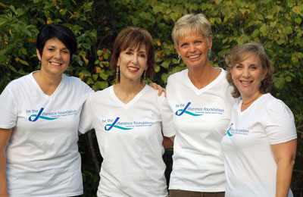
ABOUT BE THE DIFFERENCE FOUNDATION -- Jill Bach, Helen Gardner, Lynn Lentscher and Julie Shrell, each ovarian cancer survivors, wanted to give back and be the difference in the fight against ovarian cancer and formed Be the Difference Foundation. Since its inception in 2012, Be the Difference Foundation has raised more than $3.5 million for the fight against ovarian cancer through Wheel to Survive events in Dallas, Austin, Houston, Lubbock, South Florida, San Diego, San Francisco, Denver and Boulder.

SOUTH CAROLINA 2021 SPONSORSHIP LEVELS

Thank you for your interest in supporting Wheel to Survive 2021. Please review the benefits associated with each sponsorship level below and indicate which level best fits your support by checking the circle next to it. Please sign and complete the agreement at the bottom of this page. Scan and return this document along with your print ready logo and the exact name you want used when referring to your sponsorship to: Jon Mize, jmize@bethedifferencefoundation.org. Sponsorship payments are due upon signing and should be made payable to Be the Difference Foundation and mailed to, Be the Difference Foundation, Attn: Wheel to Survive South Carolina, PO Box 540954 , Dallas, Texas 75354.

- $7,500 BEING THE DIFFERENCE
  - Prominent logo placement as BEING THE DIFFERENCE sponsor on event collateral including: WHEEL TO SURVIVE webpage; Top tier of sponsor logos on rider t-shirts, event signs, promotional materials and sized larger than other sponsor logos
  - Display of sponsor’s banner (provided by sponsor) at event
  - Product samples and collateral provided by sponsor inserted in rider goody bags
  - Link to sponsor website and social media channels
  - Feature article spotlighting your sponsorship support in monthly e-newsletter
  - TITLE SPONSOR press release sent to media introducing your company’s relationship to the event
  - Sponsor name included in press releases with reference as TITLE SPONSOR
  - Opportunity for participation in the WHEEL TO SURVIVE indoor cycling event for a team of 12 riders on four reserved bikes with waived registration fees and TITLE SPONSOR recognition displayed on the bike

- $5,000 CELEBRATING THE DIFFERENCE
  - Logo placement as CELEBRATING THE DIFFERENCE SPONSOR on event collateral including: WHEEL TO SURVIVE webpage; 2nd tier of sponsor logos on rider t-shirts, event signs, promotional materials
  - Display of sponsor banner (provided by sponsor) at event
  - Product samples and collateral provided by sponsor inserted in rider goody bags
  - Link to sponsor website and social media channels
  - Sponsor name included in press releases and e-newsletters
  - Three reserved bikes for a team of up to 9 riders with waived registration fees at the WHEEL TO SURVIVE indoor cycling event with corporate logo displayed on bike

- $2,500 MAKING THE DIFFERENCE
  - Logo placement as MAKING THE DIFFERENCE SPONSOR on event collateral including: WHEEL TO SURVIVE webpage; 3rd tier rider t-shirts, event signs, promotional materials
  - Product samples and collateral provided by sponsor inserted in rider goody bags
  - Link to sponsor website and social media channels
  - Sponsor name included in press releases and e-newsletters
  - Two reserved bikes for a team of up to 6 riders with waived registration fees at the WHEEL TO SURVIVE indoor cycling event with corporate logo displayed on bike

- $1,000 INVESTING IN THE DIFFERENCE
  - Logo placement as INVESTING IN THE DIFFERENCE SPONSOR on event collateral including: WHEEL TO SURVIVE webpage; 4th tier rider t-shirts, event signs, promotional materials
  - Product samples and collateral provided by sponsor inserted in rider goody bags
  - Link to sponsor website and social media channels
  - Sponsor name included in press releases and e-newsletters.
  - Reserved bike for a team of up to 3 riders with waived registration fees at the WHEEL TO SURVIVE indoor cycling event with corporate logo displayed on bike

- $500 SUPPORTING THE DIFFERENCE
  - Logo placement as SUPPORTING THE DIFFERENCE SPONSOR on event collateral including: WHEEL TO SURVIVE webpage, rider t-shirts, event signs, promotional materials
  - Link to sponsor website and social media channels
  - Product samples and collateral provided by sponsor inserted in rider goody bags
  - Corporate logo displayed on bike

Authorizing Signature:___________________________________ Date:_______________________________________

Print Name: __________________________________________ Sponsor Name:________________________________

Address:_____________________________________________ City:________________ST:________Zip:___________

Events & Corporate Partnerships Director: Jon Mize, 214-418-2046, jmize@bethedifferencefoundation.org

